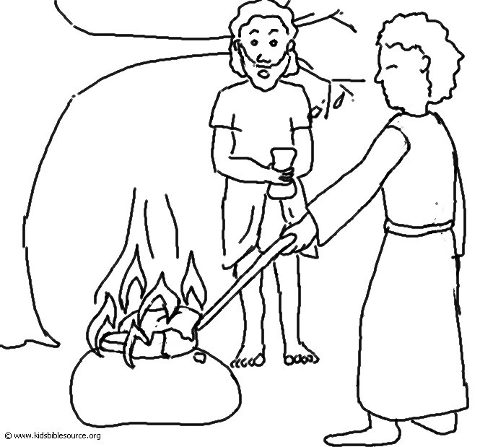
Do not be afraid …for the Lord your God will …never fail you.
Deuteronomy 31:6_{NLT}

